Challenge Section 15 processes
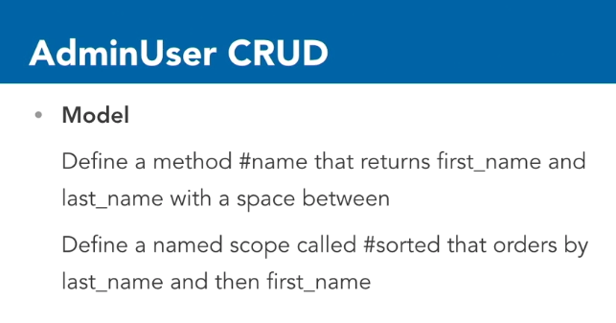
Model – method to return name – first_name last_name
in admin_user.rb
Changes to AdminUser class
def name
"#{first_name} #{last_name}"
# Or: first_name + ' ' + last_name
# Or: [first_name, last_name].join(' ')
end

scope :sorted, lambda { order ("last_name ASC, first_name ASC") }

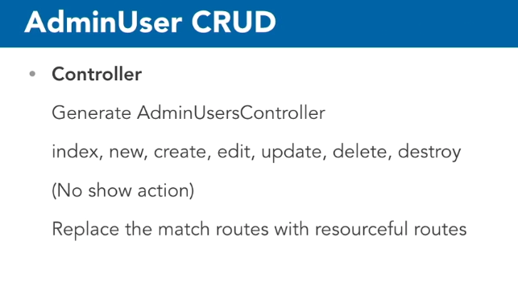
Controller -
rails generate controller AdminUsers index new edit delete
Routes -
remove the static simple match routes that it added automatically - instead use a resourceful route:
resources :admin_users do
member do
get :delete
end
end
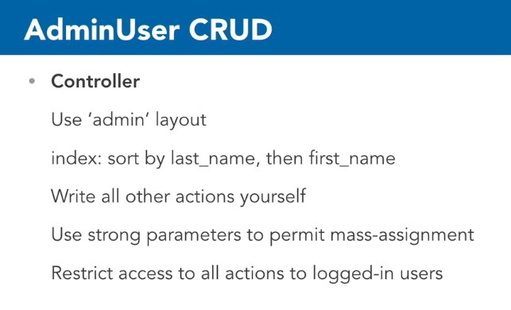
Controller
admin_users_controller.rb
layout 'admin' # generic header, footer, CSS
before_action :confirm_logged_in
def index
@adminUsers = AdminUser.sorted #default sort defined in subject model
end

def new
@adminUser = AdminUser.new()
end
def create
# Instantiate a new object using form parameters
@adminUser = AdminUser.new(adminUser_params) #private def below
# Save the object
if @adminUser.save
# If save succeeds, show notice and redirect to the index action
flash[:notice] = "Admin created successfully."
redirect_to(admin_users_path) # resourceful route back to index page
else
# If save fails, redisplay the form so user can fix problems
render('new') # new.html.erb - this does not perform the new action. This just renders that form template
end
end

def edit
@adminUser = AdminUser.find(params[:id])
end

def update
# Find a new object using form parameters
@adminUser = AdminUser.find(params[:id])
# Update the object
if @adminUser.update_attributes(adminUser_params) #private def below
# If save succeeds, show notice and redirect to the show action
flash[:notice] = "Admin updated successfully."
redirect_to(admin_user_path(@adminUser)) # call show.html.erb
else
# If save fails, redisplay the form so user can fix problems
render('edit')
end
end

def delete
@adminUser = AdminUser.find(params[:id])
end
def destroy
@adminUser = AdminUser.find(params[:id])
@adminUser.destroy
# show notice and redirect to index
flash[:notice] = "Admin '#{@adminUser.name}' destroyed successfully."
redirect_to(admin_users_path)
end

def adminUser_params
params.require(:admin_user).permit(:first_name, :last_name, :email, :username, :password, :created_at)
end
Password is one of the virtual attributes. It was added for us by has secure password. It doesn't exist on the database. In the database table we have password digest but we do not want to permit that. No user should be able to edit password digest. It's there for has_secure_ password – in admin_user model - to manage. We want to give them a form field for password that they can fill out.

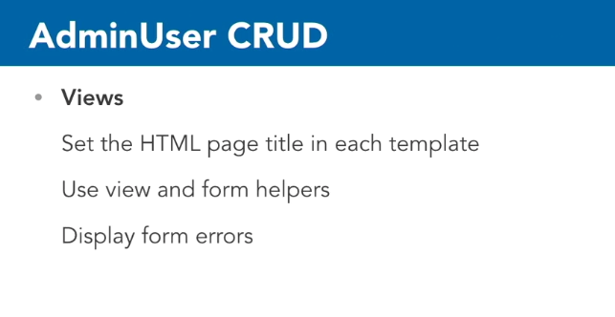
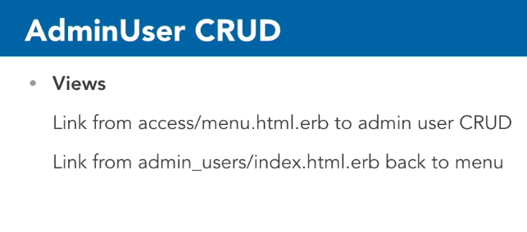
Views

– use copies of previous templates (subject, pages. Etc. ) and make changes as appropriate
Differences – mail_to(adminUser.email) – creates link to email program, passing the email address
Password –
in _form.html.erb -
<th>Password</th>
<td><%= f.password_field(:password) %></td>

password is a virtual attribute but we do want to allow the users to put values in there that they can be submitted for has_secure_password to manage.

Main Menu – menu.html.erb - make link for Admin User
<li><%= link_to("Manage Admin Users", admin_users_path) %></li>
All indexes pages – link back to menu
<%= link_to("Return to Main Menu", admin_path) %>

